Driving route to the falls
The maps below show 14 easily accessible waterfalls in Southern Oregon that connect via a driving route between Roseburg and Medford. Both of these cities are largely populated and will have everything you may need to pick up before beginning your adventure into the wilderness!
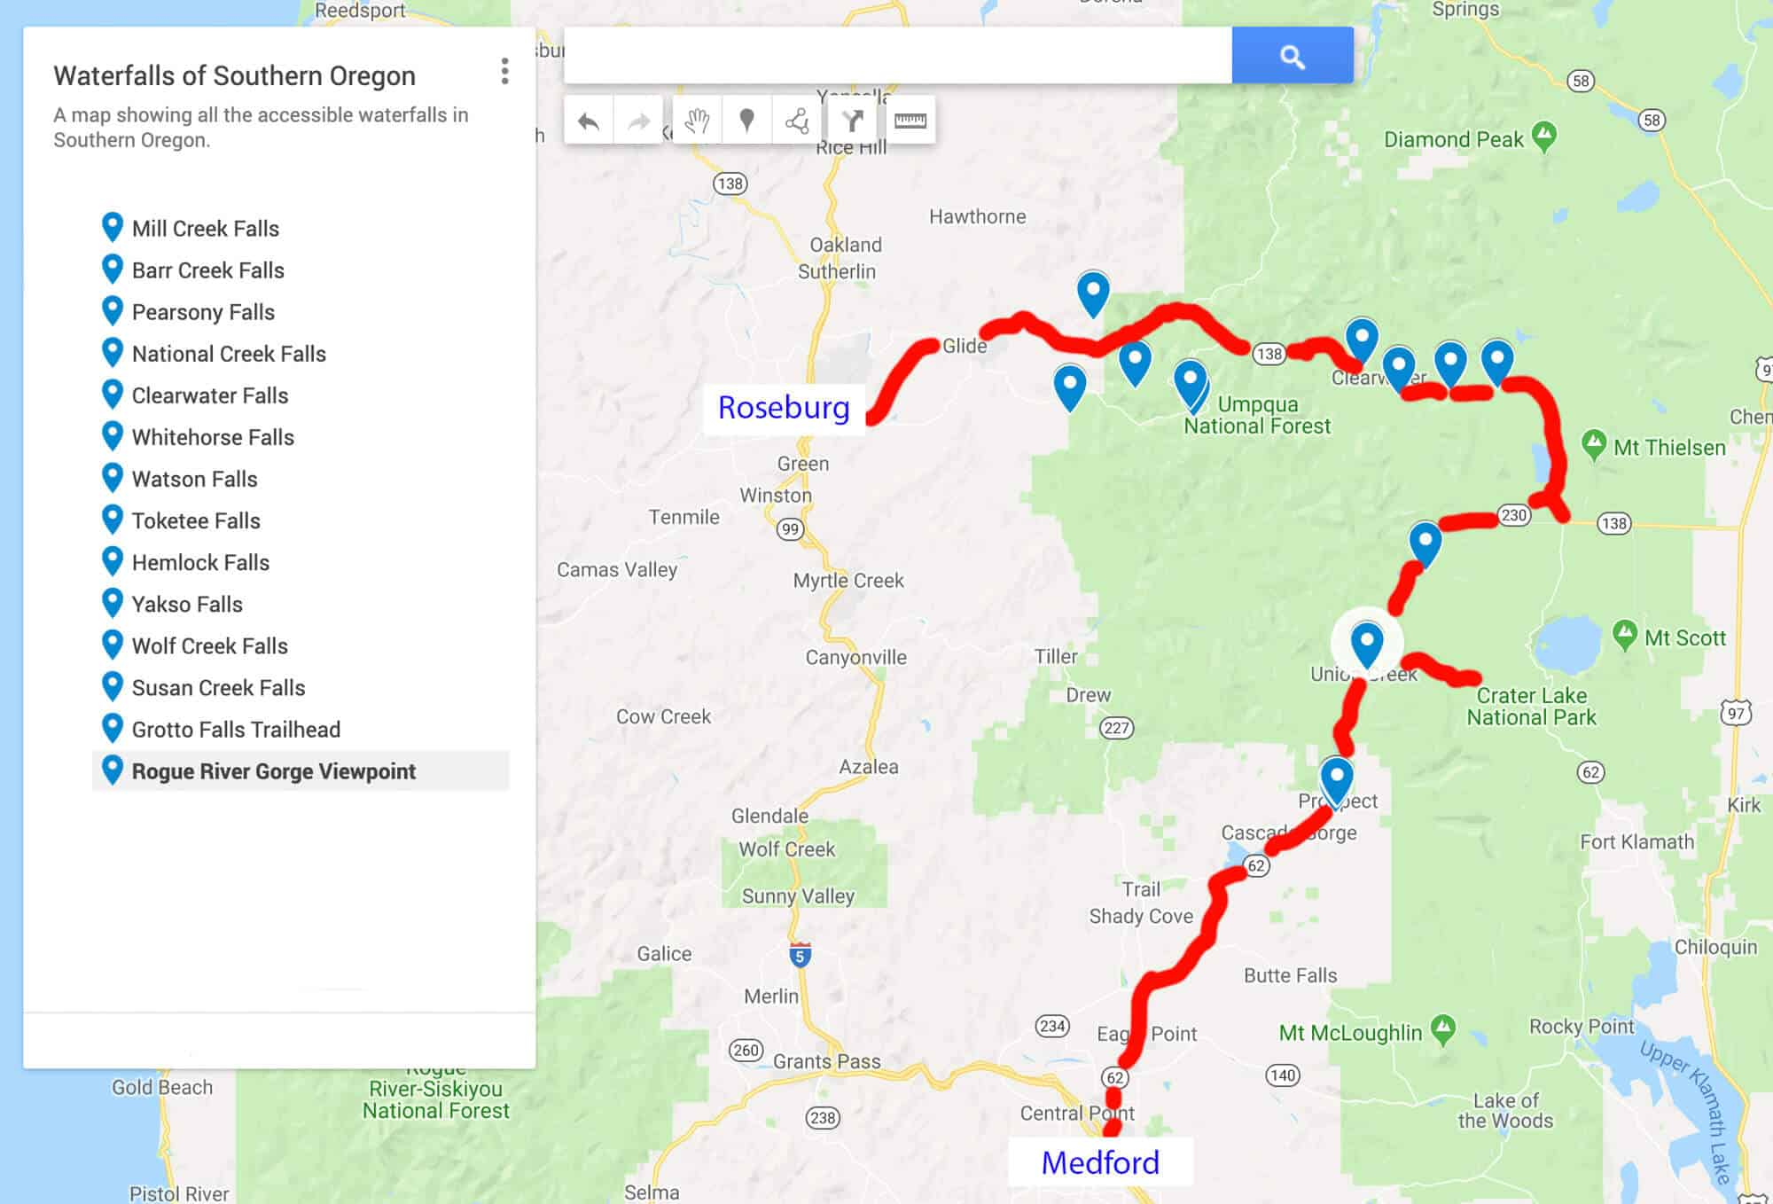Waterfall drive itinerary; one way, Medford <-> Roseburg
As most travelers will be coming from the North, the waterfall itinerary below will start at Roseburg and end in Medford/Ashland (North to South). Of course, if you are coming from Medford or Ashland, simply reverse the order (driving South to North). The map ABOVE shows the route you will drive if only traveling one way as part of a bigger road trip.
If you are a local or want to continue your road trip via the Oregon coast instead, the map BELOW shows you how to visit all the waterfalls as a loop that ends wherever you began! Essentially, you will return to the starting point via I5, regardless of where you begin.
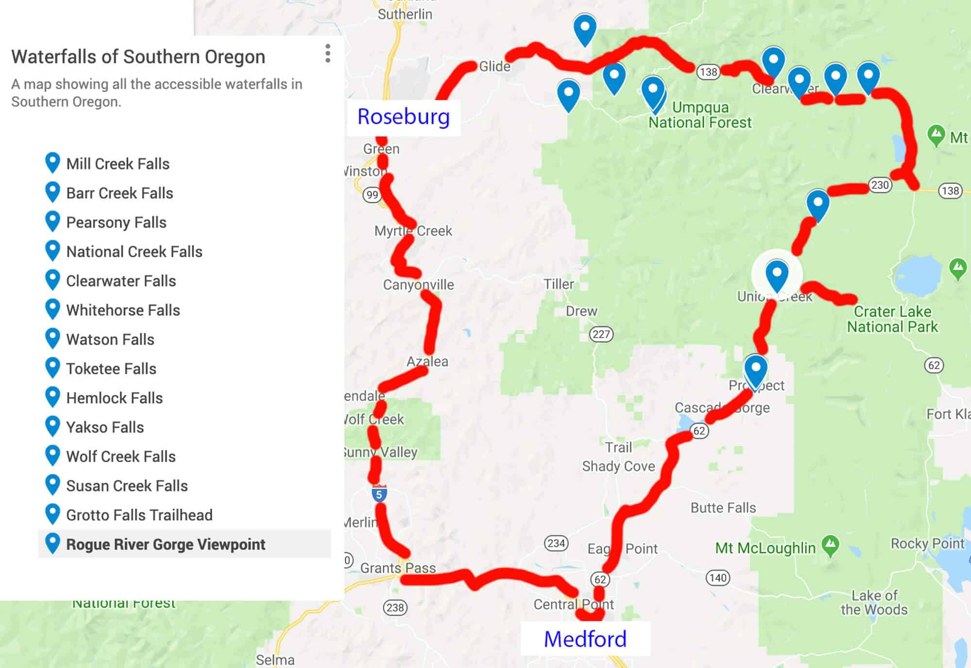
Waterfall drive itinerary; LOOP
NOTE: YOU WILL NOT HAVE MOBILE SERVICE DURING MOST OF THIS DRIVE. Make sure you’ve downloaded offline maps if you are worried about getting lost (unlikely), and check road conditions/weather forecasts if you are planning winter travel.
On that topic, this self-drive route is not advisable in the winter following heavy snowfall. Driving can be dangerous, and nearly all of the smaller roads to the waterfalls will be inaccessible as the plows clear the major highways and in doing so, completely block the roads to the falls.

Freedom camping in Southern Oregon
While the itinerary provided here can be driven in a single day, you will not be able to visit every waterfall on the route in that time. Assuming your time in Southern Oregon is part of a larger road trip, I would recommend allowing at least 2 days for this itinerary.
As for bathroom facilities, there will be toilets available in most of the waterfall parking lots.
If you plan on staying overnight as recommended, make sure you have brought sufficient food! Your only option once you have entered the Umpqua National Forest will be Beckie’s Diner in Union Creek. Your best bet is to load up in Medford or Roseburg, depending on your direction of travel.

Other waterfalls in Southern Oregon
Before getting into the waterfall drive itinerary, I must point out that there are more waterfalls in Oregon than in any other state. In fact, it would take you weeks to visit all the falls in Douglas County alone!
While I absolutely encourage you to visit them if you have no time constraints and good weather, they have not been included in this itinerary for a few reasons.
Some require substantial detours from our route or have frequent accessibility issues, and some just require longer hikes than I felt most people would be interested in. However, below is a list of all of the waterfalls near Roseburg and Glide that I am aware of to help you decide if you would like to include any of them on your holiday.
- Susan Creek Falls
- Little Falls
- Steamboat Falls
- Jack Falls
- Fall Creek Falls Waterfalls
- Grotto Falls
- Emile Falls
- Shadow Falls
- Warmspring Falls
- Lemolo Falls
- Deer Lick Falls
- Lemolo Falls
- Duwee Falls
- Ruth Falls
- Rough Rider Falls
- Vidae Falls
- Stuart Falls
YOU MAY ALSO ENJOY: Top 15 Waterfalls in Oregon

Itinerary: Photographing the Waterfalls in Southern Oregon
Below is a listing of all the waterfalls we will be visiting on the drive to or from Medford and Roseburg. I have also included photography from each of the falls, as well as travel distance, drive time, and hiking distances.

Wolf Creek Falls
(from Roseburg)
Drive time: 45 minutes
Distance: 32 miles
Hike to Wolf Creek Falls: 1.2-mile roundtrip
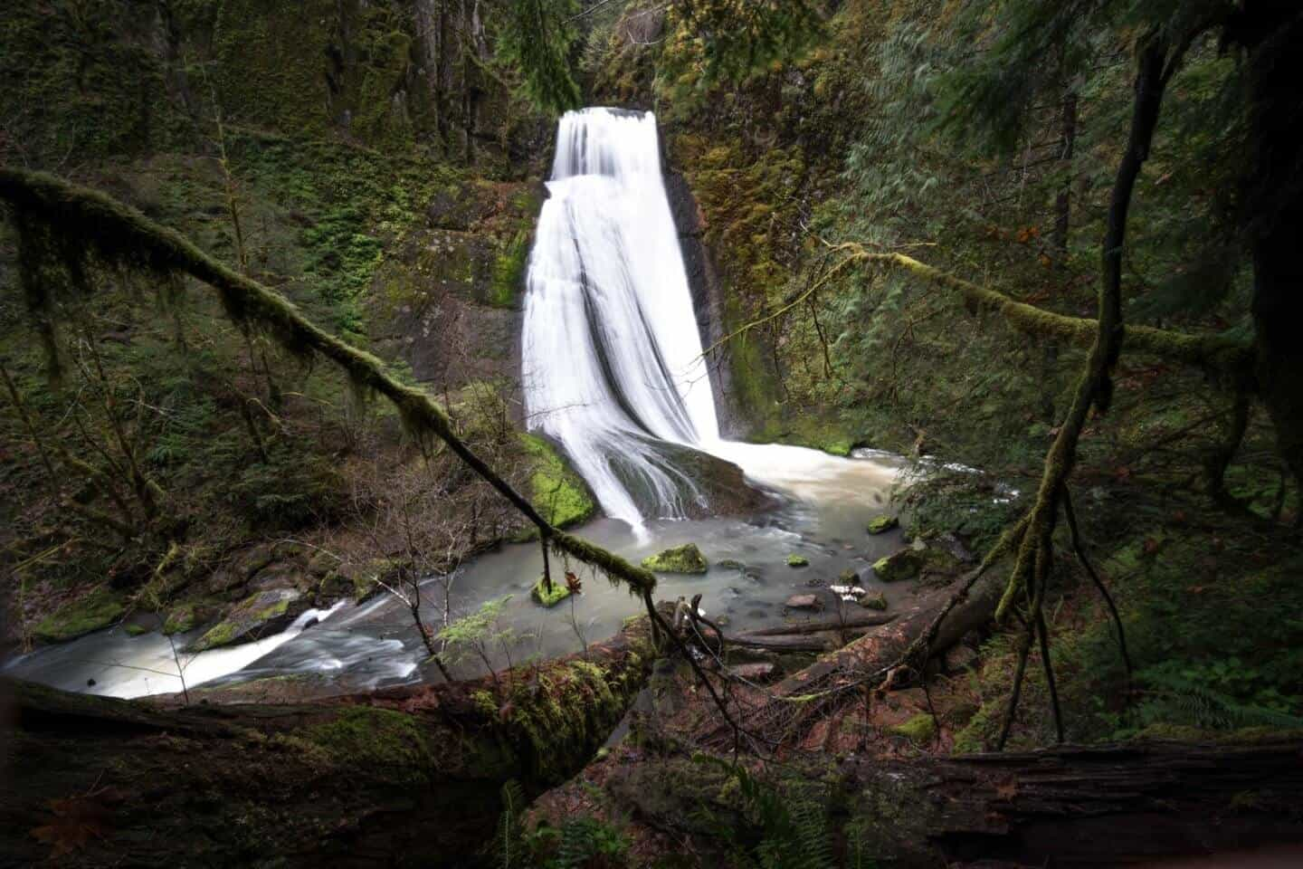The twisted Wolf Creek Falls outside of Roseburg, Oregon.
We will begin with the closest waterfall to Roseburg/Glide, known as Wolf Creek Falls. This first stop is a fitting place to begin your journey, as you will actually be getting two waterfalls for the price of one!
As you near the falls, you will first come across a vantage point of a small waterfall in front of the actual Wolf Creek Falls. It was difficult to get an unobstructed view, but I did find a composition I liked using a fallen log as a leading line (see below).
While this was not necessarily my favourite of the falls, I do enjoy its unique, twisted appearance. Its almost as if someone tried warping it in photoshop!
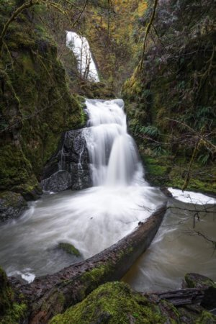Wolf Creek Double Feature!

Yakso Falls, Hemlock Falls, & Lake in the Woods
(from Wolf Creek Falls)
Drive time: 37 minutes
Distance: 16 miles
Hike to Yakso Falls: 1.4-mile roundtrip
Hike to Hemlock Falls: 1-mile roundtrip
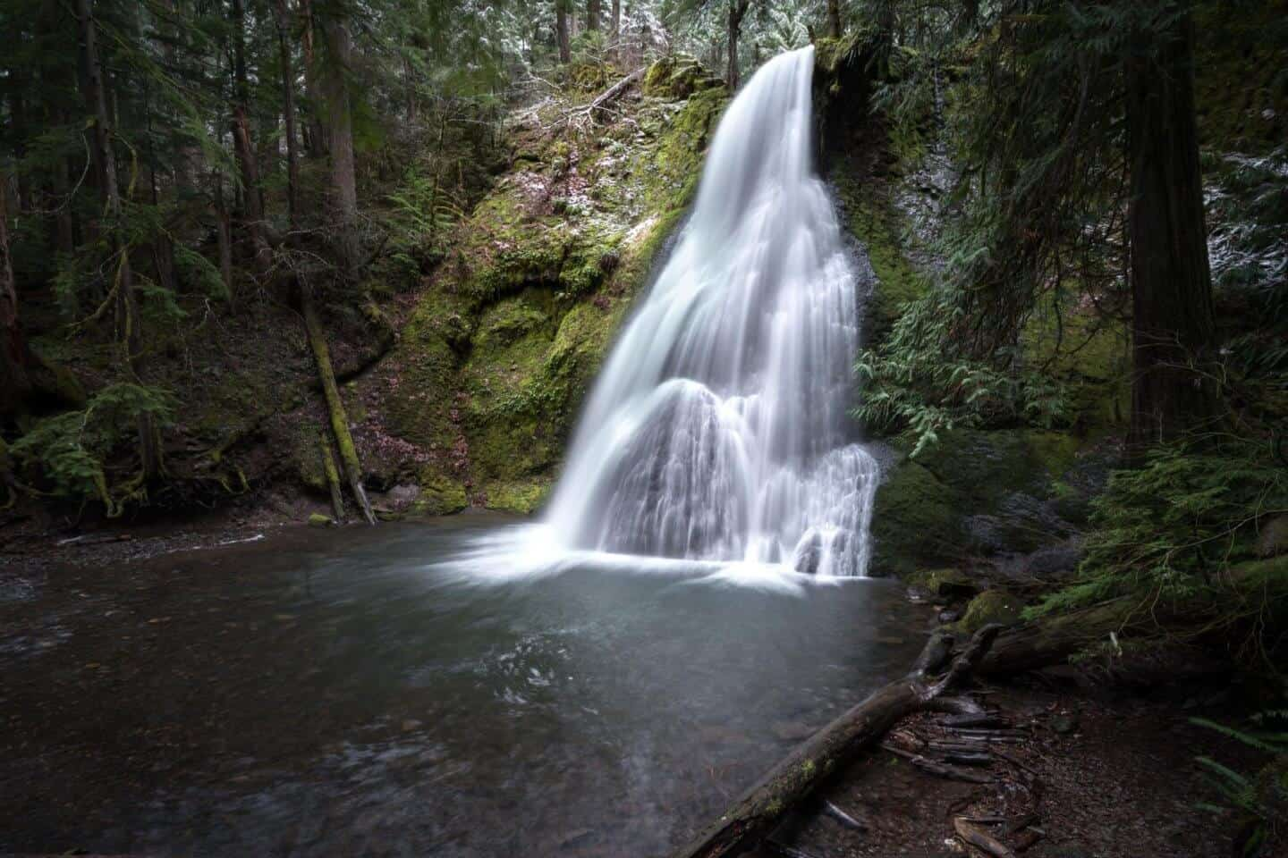A fresh snow dusting decorates the mystical Yakso Falls.
Our next stop is yet another double feature (triple if you count Lake in the Woods!). Southern Oregon is the gift that keeps on giving!
To find the waterfalls, set your GPS guidance to Lake In the Woods campground. If you are not using GPS, just follow Little River Road (which you should already be on) 16 miles until you’ve reached the campground.
Lake in the Woods is a beautiful destination in and of itself. We were treated to a freak, unexpected snow dusting on our last visit, which made for some epic photos. The trailheads to Yakso Falls and Hemlock Falls both begin at the campground as well.
Yakso Falls required only a short walk through some beautiful woods and delivered my preferred photography opportunity of the two. You can easily walk down to the falls or shoot from higher up on the trail. I loved the way the large boulder at the bottom broke up the flow of water, as well as the emerald green color of the water.
Hemlock Falls is likely impressive other times of the year, but was underwhelming when we visited. There are three levels (Upper, Middle, and Lower) that are accessible outside the winter months. Unfortunately, the weather prevented us from accessing most of the Hemlock Falls, and the water flow was pretty minimal. I’d love to see it in the spring, but it’s missable in the winter!
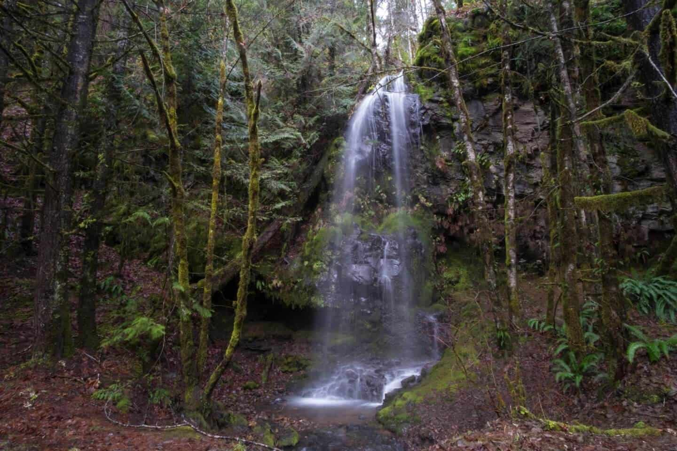Hemlock Falls is likely pretty other times of the year but was a bit sparse on our visit.
DISCOVER MORE WATERFALLS: Trail of Ten Falls – Silver Falls State Park

Toketee Falls
(from Lake in the Woods Campground)
Driving Time: 1 hour
Distance: 35 miles
Hike to Toketee Falls: 1.5-mile roundtrip
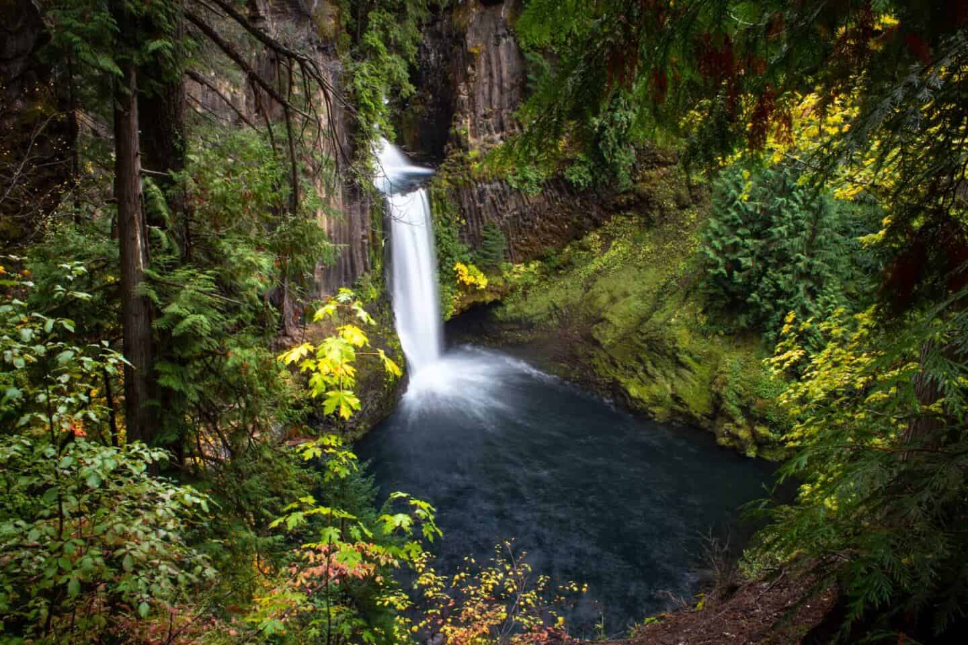The best waterfall in Southern Oregon, as seen in the colors of fall.
If you only visit one waterfall in Southern Oregon, make it Toketee Falls! This is my personal favorite in the area, perhaps in the state!
You will be departing from civilization from this point and following the North Umpqua River along Hwy 138. Expect to spend some time with your nose pressed to the glass!
Upon arrival at Toketee, the hike from the parking lot to the waterfall takes about 15 minutes if you go directly there, but you may be tempted to take some of the foot trails that wander from the main path towards the river. That will be discussed below.
You will arrive at a large, elevated boardwalk that provides a stunning view of Toketee Falls below. At first glance, it almost looks like the North Umpqua River has carved a path through ancient fossilized trees.
In fact, the rock that it flows through is columnar basalt. The viewpoint is likely to be busy from midday, and you may notice some people at the bottom. This brings us to a necessary discussion on accessing Toketee Falls directly…
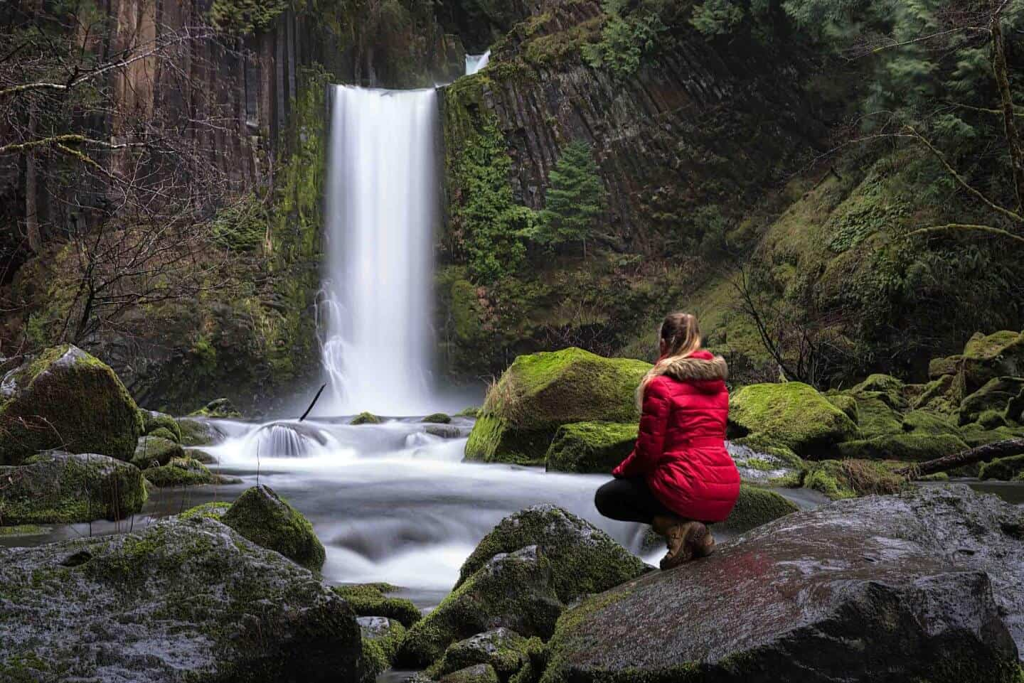Seeing Toketee Falls from the bottom is like seeing an entirely different waterfall!

Accessing the bottom of Toketee Falls
As I have made a point to mention in each of my guides, I believe that my job is not to condemn nor condone, but to inform. To that end, I will try to be concise and specific with my advice on going off-trail if you want to see some of the smaller waterfalls near Toketee Falls, or to get to the base of the main waterfall:
First, there have been multiple drownings at Toketee Falls in the past few years. HOWEVER, contrary to popular belief, these deaths were not caused by the rope trail that leads to the bottom of the falls!
As you will surely discover, it would be very difficult to slip and fall to a watery death from here, as you are a long way away from the river. It is, however, a slippery and difficult climb and there is a realistic risk of injury.
If you decide to attempt the climb down, bring proper shoes and do not attempt in snowy or muddy conditions. Finding the way down should be pretty obvious, just look for the hole in the fence at the viewpoint.
As for going off-trail during the hike to the falls, there are some beautiful spots to do so, just please do not stand too close to the edge. There are obviously no railings and if you were to fall into the gorge, you would not be getting out. That said, there is nothing inherently dangerous in most of these areas as long as you do not get too brave near the water’s edge.
All that aside, I am an absolute nature lover and it is my belief that we are meant to enjoy its beauty however we connect to it. For me, that means with a tripod and camera. For others, standing on the viewing platform is enjoyment enough. There are even some who live for adrenaline-inducing outdoor adventures, like kayaking straight over the falls!
As long as what you are doing does not damage a delicate ecosystem or alter the way of life for its inhabitants, I personally believe that, as a species, we are wired to explore. And yes, even take mindful risks from time to time.
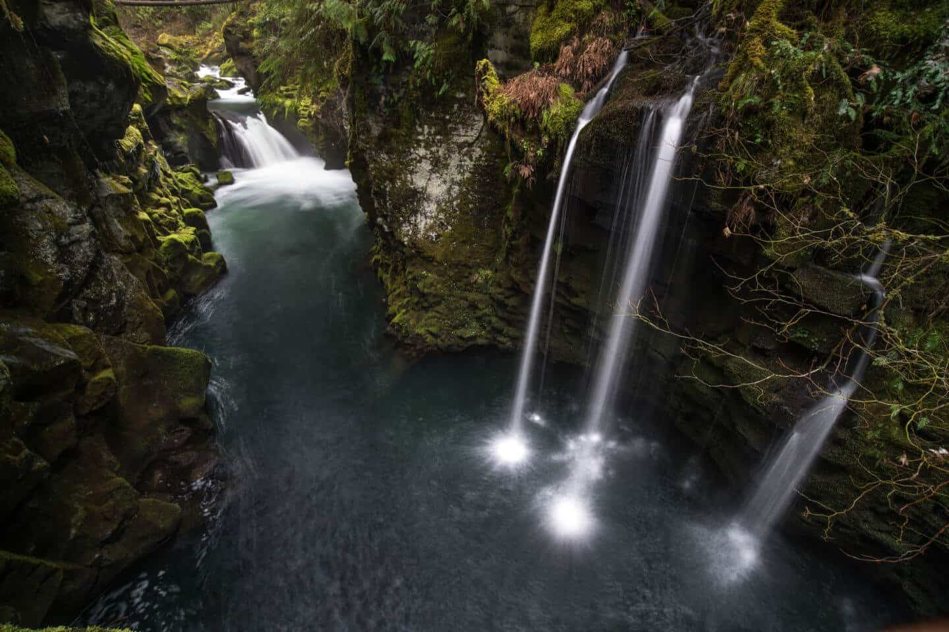A mini-waterfall that is accessible from a side trail on the walk to Toketee Falls.
YOU MAY ALSO ENJOY: Best Places to Visit in Oregon

Watson Falls
(from Toketee Falls)
Drive Time: 5 minutes
Distance: 3 miles
Hike to Watson Falls: 1.2 (steeper grade than any other so far)
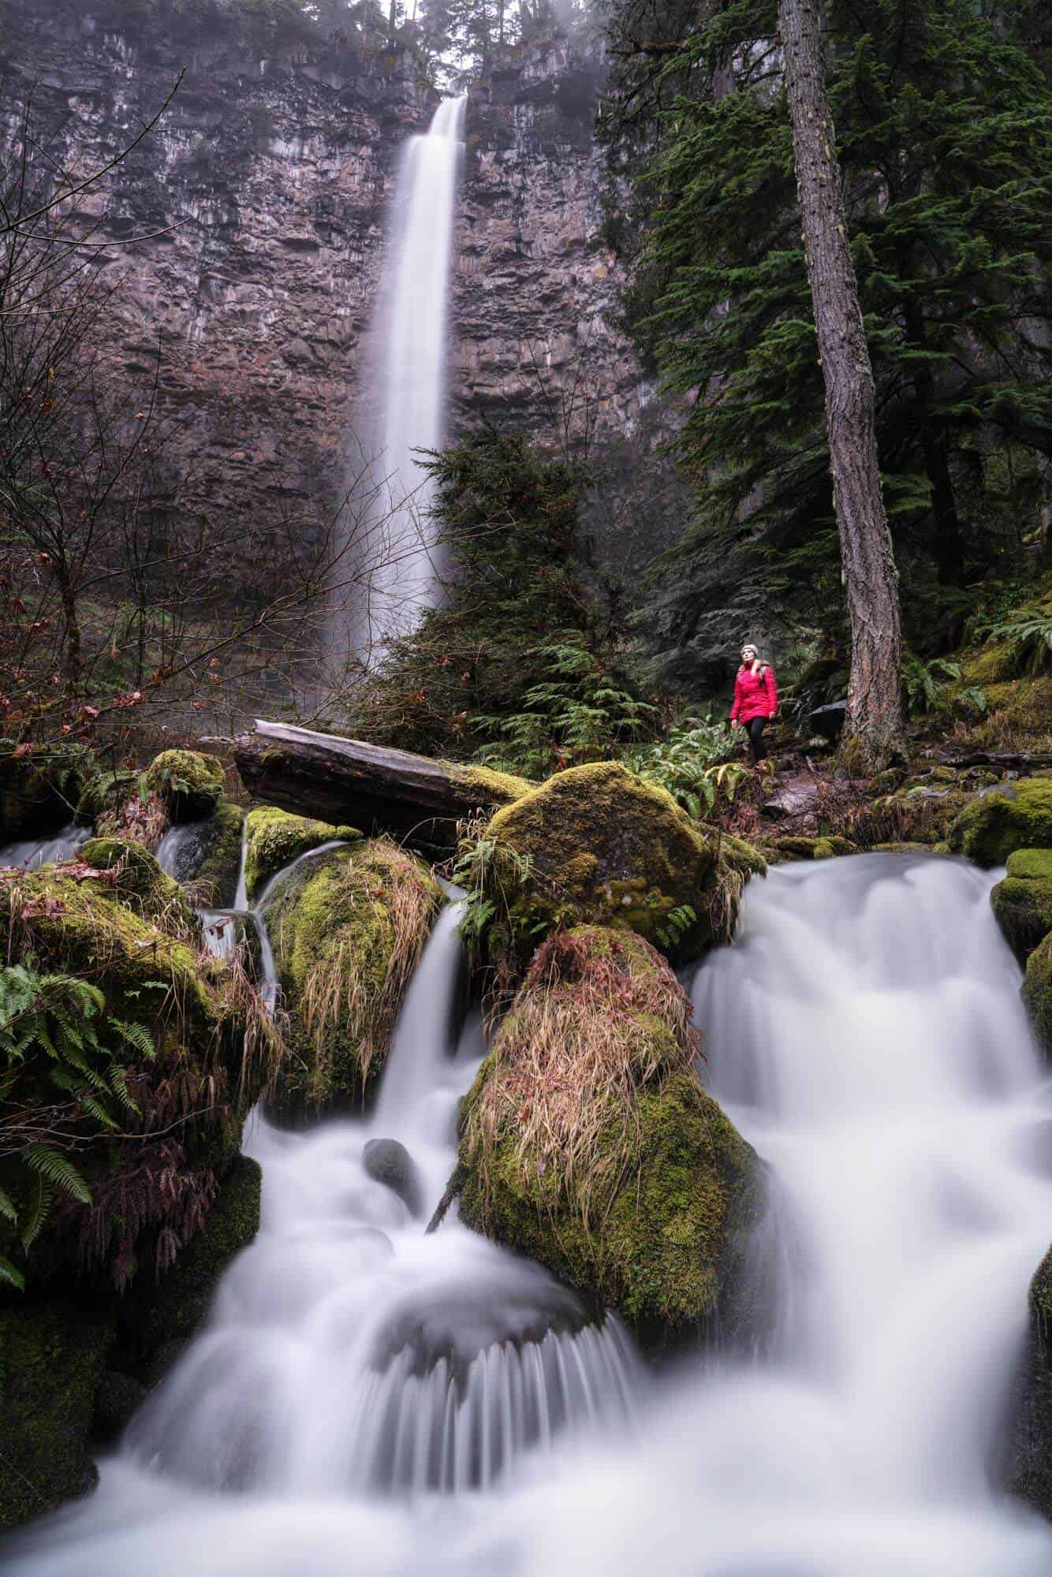Watson Falls is the tallest waterfall in Southern Oregon, and among the prettiest!
Now we have entered the thick of things! There are 4 waterfalls near Toketee Falls alone, all within 15 minutes of each other by car.
Only a 5-minute drive from my favorite Southern Oregon waterfall (Toketee) and you arrive at my second favorite; Watson Falls!
At 272ft tall, Watson Falls is the largest drop of all the waterfalls in Southern Oregon and the second-highest in the state. The tallest is also the most famous waterfall in Oregon; none other than Multnomah Falls (located in the Columbia River Gorge near Portland).
Be prepared for a more strenuous hike than the others, despite only being half a mile to the top. The good news is that there are many photo opportunities on the way up the trail, meaning you will have a couple of chances to stop, set up a tripod, and catch your breath. My favorite composition is the one above. Just before arriving at the footbridge, you can see the falls looming in the distance with some great smaller tumbles to use as your foreground.
The best part about this waterfall is that you can walk right up to it, if you choose to do so. There are plenty of unique compositions for photography enthusiasts, and a comfortable viewing platform for those who want to sit and enjoy.

Whitehorse Falls
(from Watson Falls)
Drive Time: 7 minutes
Distance: 5 miles
Hike to Whitehorse Falls: NoneIt may be small, but Whitehorse Falls feels like it’s set in an enchanted forest!
After hiking to Toketee and Watson Falls, you will be relieved to know that Whitehorse Falls requires no hike whatsoever! It also has a nice picnic area and restroom facilities if you want to stop for lunch or take a break.
As for the waterfall itself, Whitehorse is considered mediocre when measured against most Oregon waterfalls… the drop is very small, and by this point, you may be acclimating a bit to the brand of wilderness that the Umpqua National Forest provides. However, from a photography standpoint, Whitehorse Falls ROCKS!
What I love about this little waterfall are the criss-crossing logs that form a perfect X shape. With a wide enough angle lens, you should be able to fit the entire scene in one frame from the viewpoint, which results in a photo that is thought by most to be better than the reality.
As a quick aside, one of our Winter Photography Workshops was a full day of photographing the Southern Oregon waterfalls. Whitehorse Falls was our final stop of the day, sneaking in this bonus winter scene just as the light was fading. Our goal was to teach our students about the considerations that go into including a human element in a landscape photo. As this waterfall is small, we didn’t want to shrink it further by being too tall, and the outfit choice will always affect the mood. Out came the famous red dress and with a few cheers, I made my way to lie down on the log!
The photo below is from our camera. However, one of our students went on to win first prize in that month’s Grants Pass Photography Photo contest (way to go Cynthia!) with her version of “Lady in Red”!
I love how the red adds that pop of color against the pure white snow.
YOU MAY ALSO ENJOY: The Best Southern Oregon Photography Locations

Clearwater Falls
(from Whitehorse Falls)
Drive Time: 9 minutes
Distance: 5.8 miles
Hike to Clearwater Falls: None
The aptly named Clearwater Falls flows clumsily through a mossy forest.
Another great place to picnic, Clearwater Falls is the most unique one we’ll explore on our 1-2 day itinerary. Rather than featuring a large plunge, the water here tumbles clumsily over vibrant, mossy rocks and logs before draining into the aptly named Clearwater River.
I have always loved this waterfall for its special character but found it challenging to capture the true essence of Clearwater in a frame. If you have been to Ramona Falls or Proxy Falls, two of the more famous Oregon waterfalls, it may remind you of a smaller version of those.
If you are interested in practicing waterfall and landscape photography in Southern Oregon, I would love to see your favorite compositions in the comments below! I’ve still yet to capture it in a way that I love.

DETOUR OPTION: Crater Lake National Park (North Entrance)
If you have the time, you should definitely add a detour to Crater Lake National Park to your itinerary! Not only do I consider it one of the best places to visit in Oregon, but it even made it to our list of Dream Destinations!
After leaving Whitehorse Falls, you will begin leaving Douglas county and entering Jackson county. After 17 miles, you will come to a junction (just past Diamond Lake) as you journey south. We will be taking Hwy 230 to Medford/Ashland/Central Point.
However, if you are traveling in the summer months, you MIGHT also have the option of staying on Hwy 138 instead and entering Crater Lake National Park via the North Entrance.
BE WARNED: the North Entrance IS ONLY OPEN IN THE SUMMER MONTHS! The earliest it will open is late May, but each year is different. As an example, this year (2021) the North Entrance was closed to visitors until May 28th. However, in 2019 and 2020 it didn’t open until mid-June.
You can still visit Crater Lake via the South Entrance which is open year-round. Read below to see how that fits into our itinerary.

National Creek Falls
(from Clearwater Falls)
Drive Time: 50 minutes
Distance: 33 miles
Hike to National Creek Falls: 1.4-mile roundtrip
A long exposure photo of National Creek Falls.
Be warned that the drive to National Creek Falls requires a bit of a detour down a forest service road, but we were able to visit in a camper van even in the winter using Forest Road NF-6530.
While this waterfall hits all the bullet points of a great photo opportunity on paper, I have always struggled to capture it in a way that translates to a photograph. The light is often extremely harsh here, and fallen trees can cause large obstructions. This seems to be more prevalent in the winter months.
Still, National Creek Falls is on your natural driving route anyway and absolutely worth a stop. If you’re navigating without GPS, you’ll need to keep your eyes on your odometer from the time you leave Clearwater Falls as there is very little signage along the way.
HEADING TO THE COAST? YOU MAY ALSO ENJOY: The Best Southern Oregon Coast Locations

BONUS STOP: Rogue River Gorge & Beckie’s Diner
You will arrive at the Rogue River Gorge at the junction of Hwy 230 and Hwy 62, where you will have the option to detour to Crater Lake National Park or continue south toward Medford/Ashland. At this detour is a small town called Union Creek; home to Beckie’s Diner. This will be your only hot food option throughout the entire loop, but is best known for their world-famous pies! Find out the seasonal specialty and grab a slice, even if you’re not hungry. Beckie’s is a prime example of vintage American diners and a quintessential part of the regional experience!
Also in Union Creek is the Rogue River Gorge. While this is not the most photogenic stop along the drive, it is worth a peek if you have the time.

DETOUR OPTION: Crater Lake National Park (South Entrance)
(from Union Creek)
Drive Time: 41 minutes (1 hour, 22 minutes roundtrip detour)
Distance: 33 miles (66-mile roundtrip detour)
Hike to Crater Lake: None
A stunningly beautiful winter scene of snowy Wizard Island in Crater Lake, taken at sunrise.
I know it’s not a waterfall, but no Southern Oregon itinerary would be complete without including the most breathtaking individual sight in the entire state of Oregon… perhaps in the country! Crater Lake National Park is the deepest lake in the country, 7th deepest in the world, but most important, it is absolutely stunning!
You may have noticed that I included the detour times and distances as “roundtrip” above. This is because you will have to backtrack to Union Creek to visit via the South Entrance, which is the only entrance open most of the year.
Crater Lake at night is SPECIAL, and a premier astrophotography and star-lover destination in Oregon.
While there is the Crater Lake Lodge offering high-end accommodation, you will not be allowed to camp anywhere within the park itself. There are, however, a few campgrounds at the bottom of the mountain outside of the park itself. You will want to account for the detour time and inability to sleep here when planning your itinerary, but I think it is absolutely worth the effort.
As much as I would love to tell you all about how beautiful this park is, I think the pictures say more than I ever could. If you are into astrophotography (aka night photography), this is one of the premier destinations in Oregon to photograph the stars!

Pearsony Falls
(from Union Creek)
Drive Time: 17 minutes
Distance: 12 miles
Hike to Pearsony Falls: 0.2 miles roundtrip
Though it’s not the biggest waterfall in Southern Oregon, the wooded forest scenery feels like something from a fairytale.
Finding Pearsony Falls can be tricky as it is not sign-posted, but the good news is that it is basically in the town of Prospect. Just as you exit the tiny town, you will see an unsigned dirt parking lot on your left (or on your right just before you enter town if traveling North). It is basically across from the “gas station” there, adjacent to Gun Club Road… no joke, that’s the name of the road.
From the parking lot, it is barely a walk to the small but picturesque Pearsony Falls. You won’t find this one in many of the guide books or top waterfall lists, but it is absolutely one of my favorites to photograph; especially in autumn! You’ll encounter mossy, deciduous scenery with beautiful cascading water and a fairytale-like setting. In the fall, the golden-yellow leaves add a nice pop of color to compliment the greens.
Pearsony Falls dressed in its Autumn (Fall for all you Americans!) colours.

Mill Creek Falls/Barr Creek Falls
(from Pearsony Falls)
Drive Time: 1 minute
Distance: 0.7 miles
Hike to Prospect State Scenic Viewpoint: 0.5-mile roundtrip
The view of Barr Creek Falls from Prospect State Scenic Viewpoint is clear but a bit too distant for my taste. Someday I’ll find a way to the bottom!
We finish our road trip itinerary just as we began; with a 2-for-1 waterfall special! Don’t get too excited though, as the short hike to the viewpoints for Mill Creek and Barr Creek Falls still places you a substantial distance from the actual waterfalls.
The two falls are visible from two separate viewing areas on the trail one after the other. If you think my photo is a bit underwhelming, well, so do I. From the viewpoint, you are simply too far away to really capture the detail without a massive zoom lens, though I have no doubt both waterfalls would look stunning from closer up!
Mill Creek Falls will be the first you discover and is the smaller of the two at 173ft tall. However, your view will be mostly obstructed by trees.
Barr Creek Falls comes next, which is much taller at 242ft tall and is also more visible.
I know it is possible to get to the bottom, but I have only visited in late fall and winter months when the weather has been a bit too questionable for such an adventure. I will look to update this guide if I am able to access the waterfalls on my next visit!
One final note, you may notice Avenue of the Boulders written on the wooden map in the waterfall parking lot. Just a minute up the road is a bridge that overlooks “Avenue”, as well as the impressive Rogue Valley. It is worth a quick stop!
The Avenue of the Boulders, as seen from the bridge in Prospect (look close and you’ll see Mt Mcloughlin in the distance).
FIND MORE TRAVEL INSPIRATION: Travel Lessons from 10 Years of Exploration

Equipment for Waterfall Photography
While it is possible to capture long exposure photographs of waterfalls on your iPhone using the Live Mode option, for the best possible photos you may want to consider a few key pieces of photography gear:
- Camera: I use the Sony a7riii and have been in love with it ever since the first photo I took with it. However, for beginners you may wish to consider an entry level DSLR. This will allow you to start getting to grips with manual settings and decide whether photography is something you enjoy enough to invest in.
- Lens: The lens I use most frequently is the Sony FE 24-105mm F4 G OSS as the zoom lens allows for the most diversity. I also often use the Laowa 15mm F2 for shots that require a wider angle.
- Tripod: A tripod is essential if you want to create a long exposure waterfall image. When traveling, I use the Manfrotto Be Free as it’s lightweight and easy to carry on longer hikes. For times when I require something more stable, I use the Artcise Carbon Fiber Tripod.
- Filters: A Circular Polarizing (CPL) filter (CPL) or Neutral Density (ND) filter are very useful for allowing slower shutter speeds and for cutting glare on the water. The best CPL and ND filters I have found are the Quartzline from Polar Pro.

Things to Do in Medford and Ashland
You’ve just finished one of the most scenic drives the United States has to offer and have landed in Medford (or perhaps you are starting your journey here). What do you do now?!

What to do in Medford, Oregon
Table Rock is an iconic natural feature in Medford Oregon and an easy 45-minute hike to the top.
Medford is the hometown of one of the best photographers in Southern Oregon, Adam Marland (aka @WeOwntheMoment)… although admittedly, I may be a bit biased as he also happens to be my boyfriend (and he promised me chocolate in return for calling him the best!).
The city of Medford is the most populated in Southern Oregon and is a bit overrun with chains, but there are some local things to do and good times to be had if you know where to look. There is also a surprisingly fantastic beer and wine scene here!
If you are planning to focus your road trip on driving the coast instead of taking the freeway, you should at least do a short day trip to see the waterfalls near Medford, Oregon. In one full day, we easily covered all of the falls mentioned above out to Toketee Falls and back.
- DO: Try the Mugshot Sour Cherry Chocolate Stout at Portal Brewing. It is the best beer I have had in my entire life. Ever. Anywhere. Then, get a flight and try the rest as they are all fantastic. Walkabout Brewing, Opposition Brewing, Southern Oregon Brewing, and Bricktown are all also craft breweries in the Medford area with some solid IPAs and craft ales.
- DO: Visit historic Jacksonville! Just a 10-15 minute drive outside of town and you may think you’ve gone back in time! The best restaurants in the area are all here, and if you’re lucky enough to be there in the summer, the Brit Festival provides one of the best venues in the country for outdoor concerts.
- DO: Visit any one of the countless vineyards in the area! Southern Oregon has become a destination for wine enthusiasts, gaining fame and popularity for its Pinot Noirs.
- DO: Hike Table Rock! It’s a decent trek up, but nothing too exhausting, and provides a nice view of the city. If you are interested in photography, drive toward Table Rock for sunrise or sunset and find a nice foreground to include the pear fields in front of this locally iconic geographic feature.
- DON’T: Bother eating out in Medford. Almost every restaurant is a chain, though a few places are starting to pop up with a more local feeling. The best restaurants in the region are in Jacksonville and Ashland.
- DON’T: Stay out past 2am here! Look, realistically you’ll probably be fine. BUT, fights are almost a given on weekend nights in downtown Medford when the bars close, the city has a history of stabbings and even shootings, and the DUI rate in this small area is quite high.
Nearby Jacksonville is an escape from the fast food and retail chains, and feels like a historic city frozen in time!

What to do in Ashland, Oregon
Though only 15 minutes away on the freeway, Ashland could not be more different from Medford. Whereas Medford boasts a strongly conservative, country culture (and some unfortunate drug issues), Ashland is a liberal stronghold with a culture that prides itself on its appreciation for the arts. In its niche, Ashland is known throughout the world for the Shakespearean Festival that takes place here.
Ashland is also the only city in Oregon with a Food and Beverage tax! Despite this, it is the favorite city in Southern Oregon for most visitors. It has a good mix of college town and retiree vibes, the best restaurants in the state outside of Portland, and a constant pulse that changes with each season.
- DO: Try to attend a show at the Shakespearean Festival, if possible.
- DO: Spend some time at the beautiful Lithia Park.
- DO: Hit the hot springs for a soak in the geothermal pools.
- DO: Visit Mt. Ashland for breathtaking scenery, as well as seasonal outdoor activities.
- DO: Take an afternoon to just walk around and visit the local shops.
- DO: Visit Chocolate Falls, Oregon and let me know how it is! It is one of, if not THE only waterfall near Ashland, but is one I’ve never managed to get to!
- DON’T: Try the Lithia water at the drinking fountains. Ok, really you should, but YUCK, it tastes disgusting. It is supposedly a health tonic and, you never know, you might enjoy the flavour. Personally, I’m not a fan!

Other Oregon & Regional Guides
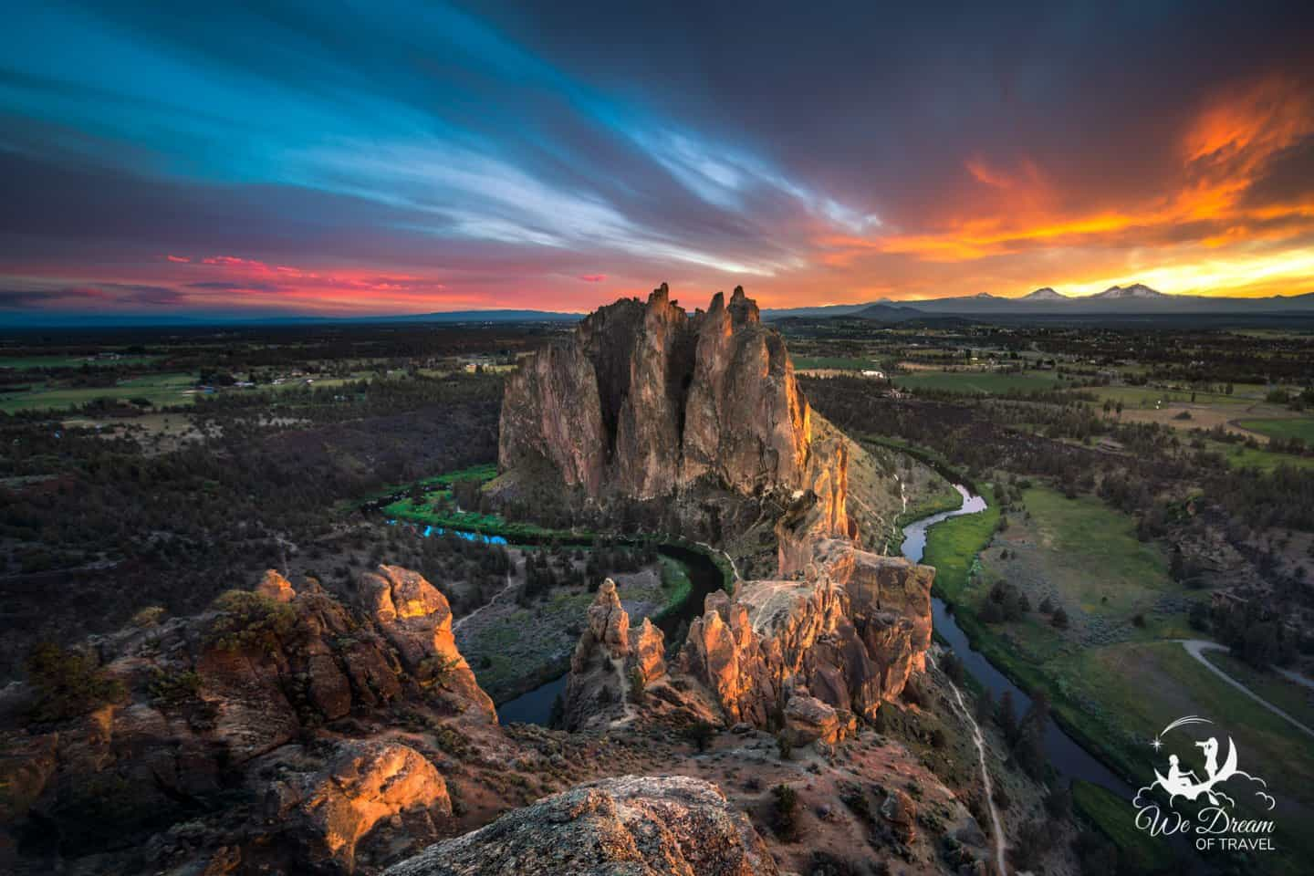Find more info about this nearby location in the Best Things to do in Oregon guide.
If you are planning an extended visit to the Pacific Northwest or crossing the border to Northern California, you may find some of the following guides useful:

Oregon Guides
- The Best Things to Do in Oregon: Nature, Arts, Events, & More
- Southern Oregon Photography Locations
- Southern Oregon Coast Guide
- Top 15 Places to Visit in Oregon
- Top 10 Places to Visit on the Oregon Coast
- Top 15 Waterfalls in Oregon
- Silver Falls State Park & Trail of Ten Falls Complete Guide
- The Complete Thor’s Well Guide
- The Complete Painted Hills of Oregon Guide

Northern California Guides
- The Ultimate NorCal Road Trip Itinerary Guide
- What to see in Shasta-Trinity National Forest
- Complete Guide to Burney Falls in NorCal
- Yosemite Itineraries: How to Spend 1-3 Days in Yosemite NP
- Yosemite Photography Guide
- Yosemite Sunrise Guide
- The Ultimate Guide to Yosemite Firefall

Washington & PNW Guides
- Olympic National Park Photography Guide
- Vancouver Island: The Perfect Road Trip Itinerary
In addition, there are some photography improvement guides that are valuable for those looking to improve in the craft.
- Long Exposure Waterfall Photography
Finally, feel free to browse our Oregon professional photography gallery for prints and inspiration.

Final thoughts on Waterfalls in Southern Oregon
As you may have realized by now, there are many beautiful waterfalls in Southern Oregon. I hope you have found this guide useful and enjoy some of the spectacular nature Oregon has to offer.
If you notice anything that requires updating or think we’ve missed something then let us know! We always love hearing from you – leave us a comment below.

Enjoyed our Waterfalls in Southern Oregon (Photography Guide)? PIN IT!?
TwitterPinterestFacebook
Share
Post navigation
Complete Kuang Si Falls 2022 Guide with Secret Pools and More
Complete 2022 Guide to Huay Mae Khamin Waterfall, Thailand

8 thoughts on “Waterfalls in Southern Oregon: A Local Guide & Itinerary 2022”
Lisa
June 22, 2019 at 8:45 am
Such a great guide and stunning photos. I love waterfalls too. I have only had two days in Oregon on a business trip and desperately want to get back to the US to hike the amazing trails around Oregon with my hubby. Thanks so much for this guide.
Reply
Travels of Sophie
June 22, 2019 at 7:20 pm
Thank you so much Lisa! I hope you make it back to Oregon soon
Reply
Denise
June 22, 2019 at 1:02 pm
So gorgeous! I love southern Oregon, this is a great guide!
Reply
Travels of Sophie
June 22, 2019 at 7:21 pm
Thank you! Me too, it’s such a beautiful place.
Reply
Jim Dwyer
November 18, 2019 at 9:13 pm
Ever since a friend gave me a picture book of Oregon 5-10 years ago I’ve been dying to visit — but I’ve never gotten so far as planning an itinerary. This is a major help! Many Thanks!
Reply
Travels of Sophie
November 21, 2019 at 5:53 pm
I’m so happy to hear that you’ve found this guide useful Jim. I’d love to know what you think of the area when you go
Reply
Amanda Storm
August 10, 2020 at 10:17 pm
I’m heading out there at the end of this week, and your post is unbelievably helpful. Thank you for that.
And if you are willing to share any other recommendations and maybe the sea cave, it would be greatly appreciated.
Thanks,
Amanda
Reply
We Dream of Travel
August 12, 2020 at 10:15 am
Hi Amanda!! I am so glad you found this useful and hope you have an amazing trip!
We dont broadcast the sea cave publicly but I will email you more info
Reply

Leave a Comment

Comment
Name Email Website
Save my name, email, and website in this browser for the next time I comment.

welcome to we dream of travel
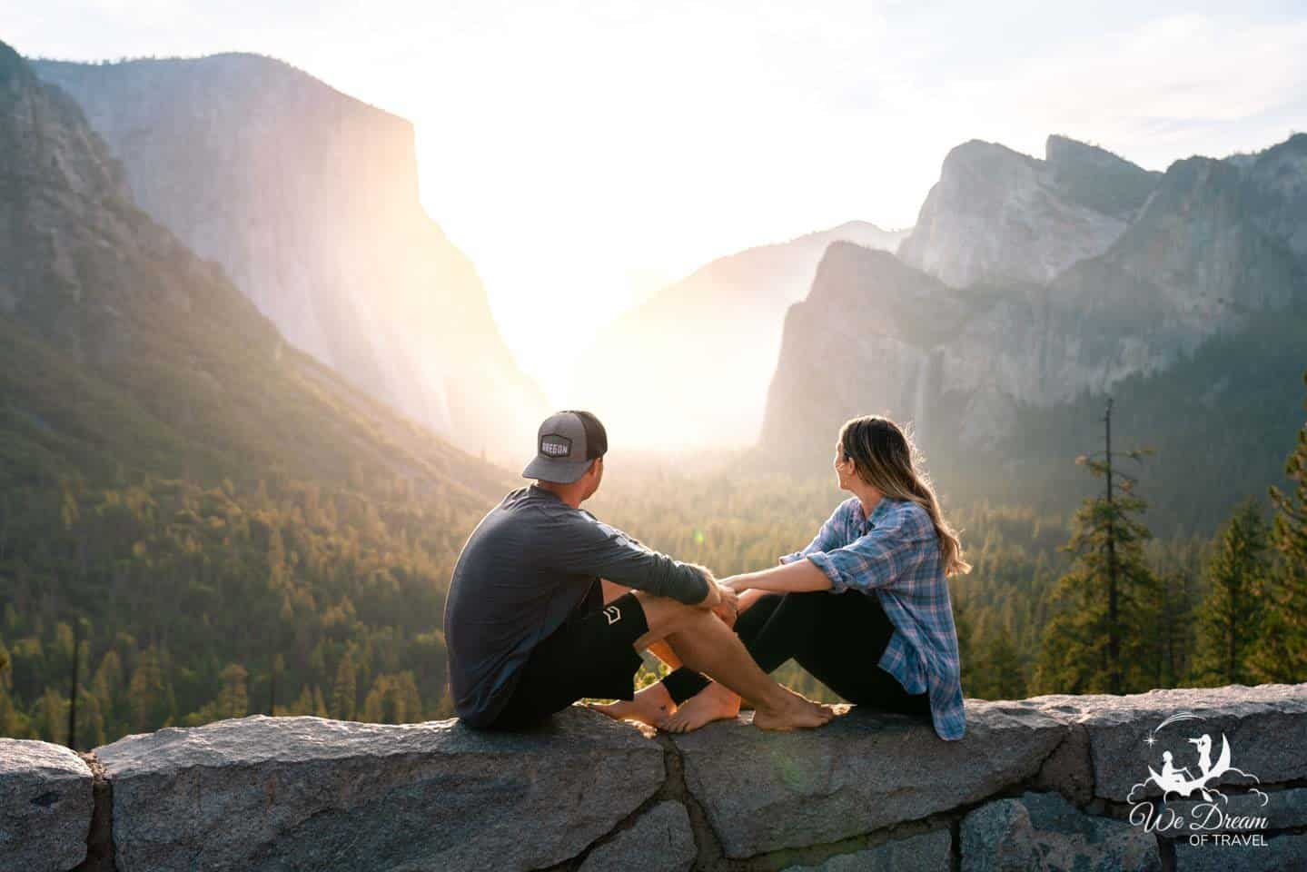
Our goal is to create helpful & inspiring travel guides that combine our passion for photography with our insatiable desire to explore.
ABOUT US

BROWSE FINE ART PRINTS
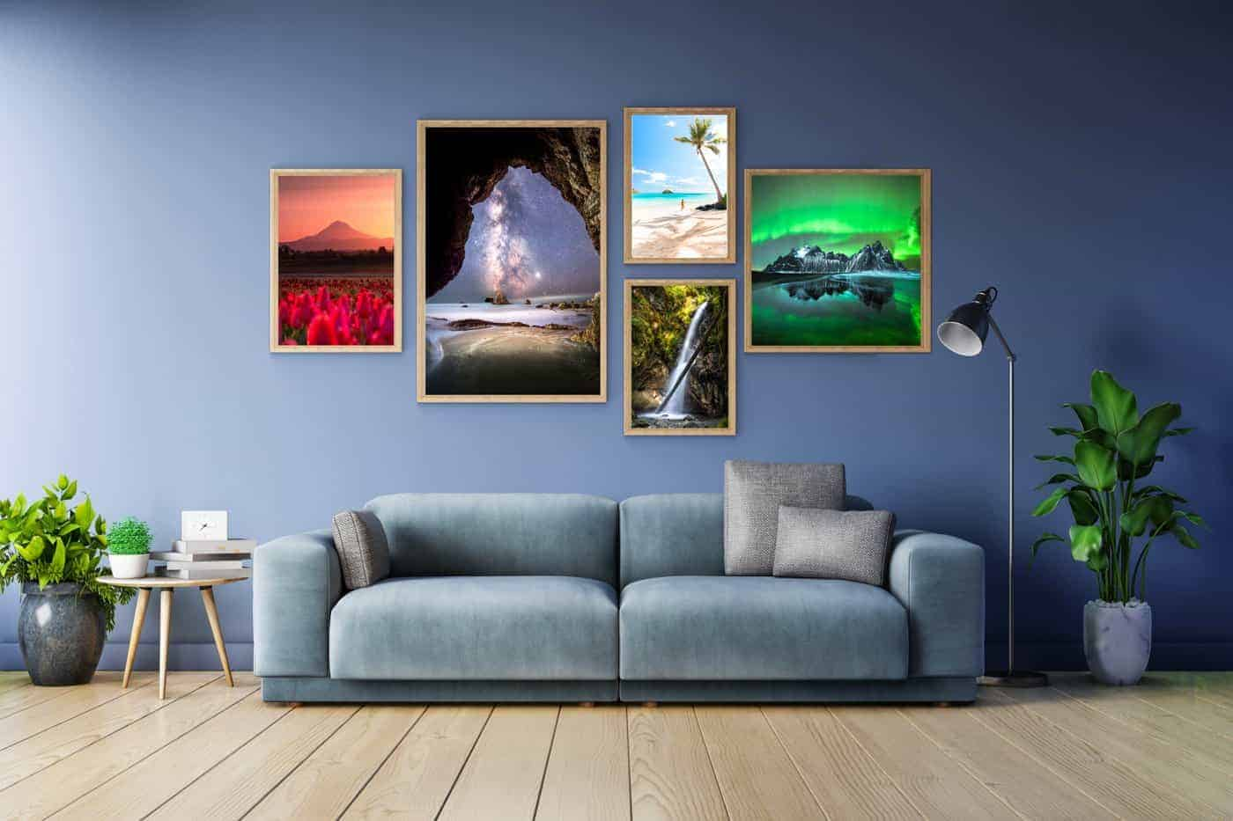
VIEW PRINT GALLERY

VISIT OUR ETSY STORE
As outdoor lovers and travel photographers, we created a store to share our joy for the natural world with affordable gifts and products.
ETSY STORE

privacy policy
We Dream of Travel is a participant in the Amazon Services LLC Associates Program, an affiliate advertising program designed to provide a means for sites to earn advertising fees by advertising and linking to Amazon.com. As an Amazon Associate, we earn from qualifying purchases.
We Dream of Travel is also a participant with the Booking.com and Get Your Guide affiliate programs. All purchases or bookings made through We Dream of Travel come at no extra cost to the reader.
fULL PRIVACY & DISCLOSURE POLICY
© 2022 We Dream of Travel
Exclusive Member of Mediavine Travel

• •
• •
• •
•

Driving route to the falls
The maps below show 14 easily accessible waterfalls in Southern Oregon that connect via a driving route between Roseburg and Medford. Both of these cities are largely populated and will have everything you may need to pick up before beginning your adventure into the wilderness!
Waterfall drive itinerary; one way, Medford <-> Roseburg
As most travelers will be coming from the North, the waterfall itinerary below will start at Roseburg and end in Medford/Ashland (North to South). Of course, if you are coming from Medford or Ashland, simply reverse the order (driving South to North). The map ABOVE shows the route you will drive if only traveling one way as part of a bigger road trip.
If you are a local or want to continue your road trip via the Oregon coast instead, the map BELOW shows you how to visit all the waterfalls as a loop that ends wherever you began! Essentially, you will return to the starting point via I5, regardless of where you begin.
Waterfall drive itinerary; LOOP
NOTE: YOU WILL NOT HAVE MOBILE SERVICE DURING MOST OF THIS DRIVE. Make sure you’ve downloaded offline maps if you are worried about getting lost (unlikely), and check road conditions/weather forecasts if you are planning winter travel.
On that topic, this self-drive route is not advisable in the winter following heavy snowfall. Driving can be dangerous, and nearly all of the smaller roads to the waterfalls will be inaccessible as the plows clear the major highways and in doing so, completely block the roads to the falls.

Freedom camping in Southern Oregon
While the itinerary provided here can be driven in a single day, you will not be able to visit every waterfall on the route in that time. Assuming your time in Southern Oregon is part of a larger road trip, I would recommend allowing at least 2 days for this itinerary.
In addition, anyone interested in photography will definitely want to add another day to visit Crater Lake National Park (more about Crater Lake at the end of this guide). It is one of my favorite Southern Oregon photography locations!
Whether you are pitching a tent or sleeping in a camper van, it is worth knowing that in the United States, freedom camping, also known as dispersed camping, is legal on all National Forest land unless noted otherwise. The general rule is to camp 100-200 feet away from any road, trail, or water source. It is not, however, allowed at National Parks (ie Crater Lake).
As for bathroom facilities, there will be toilets available in most of the waterfall parking lots.
If you plan on staying overnight as recommended, make sure you have brought sufficient food! Your only option once you have entered the Umpqua National Forest will be Beckie’s Diner in Union Creek. Your best bet is to load up in Medford or Roseburg, depending on your direction of travel.

Other waterfalls in Southern Oregon
Before getting into the waterfall drive itinerary, I must point out that there are more waterfalls in Oregon than in any other state. In fact, it would take you weeks to visit all the falls in Douglas County alone!
While I absolutely encourage you to visit them if you have no time constraints and good weather, they have not been included in this itinerary for a few reasons.
Some require substantial detours from our route or have frequent accessibility issues, and some just require longer hikes than I felt most people would be interested in. However, below is a list of all of the waterfalls near Roseburg and Glide that I am aware of to help you decide if you would like to include any of them on your holiday.
- Susan Creek Falls
- Little Falls
- Steamboat Falls
- Jack Falls
- Fall Creek Falls Waterfalls
- Grotto Falls
- Emile Falls
- Shadow Falls
- Warmspring Falls
- Lemolo Falls
- Deer Lick Falls
- Lemolo Falls
- Duwee Falls
- Ruth Falls
- Rough Rider Falls
- Vidae Falls
- Stuart Falls
YOU MAY ALSO ENJOY: Top 15 Waterfalls in Oregon

Itinerary: Photographing the Waterfalls in Southern Oregon
Below is a listing of all the waterfalls we will be visiting on the drive to or from Medford and Roseburg. I have also included photography from each of the falls, as well as travel distance, drive time, and hiking distances.

Wolf Creek Falls
(from Roseburg)
Drive time: 45 minutes
Distance: 32 miles
Hike to Wolf Creek Falls: 1.2-mile roundtrip
The twisted Wolf Creek Falls outside of Roseburg, Oregon.
We will begin with the closest waterfall to Roseburg/Glide, known as Wolf Creek Falls. This first stop is a fitting place to begin your journey, as you will actually be getting two waterfalls for the price of one!
As you near the falls, you will first come across a vantage point of a small waterfall in front of the actual Wolf Creek Falls. It was difficult to get an unobstructed view, but I did find a composition I liked using a fallen log as a leading line (see below).
While this was not necessarily my favourite of the falls, I do enjoy its unique, twisted appearance. Its almost as if someone tried warping it in photoshop!
Wolf Creek Double Feature!

Yakso Falls, Hemlock Falls, & Lake in the Woods
(from Wolf Creek Falls)
Drive time: 37 minutes
Distance: 16 miles
Hike to Yakso Falls: 1.4-mile roundtrip
Hike to Hemlock Falls: 1-mile roundtrip
A fresh snow dusting decorates the mystical Yakso Falls.
Our next stop is yet another double feature (triple if you count Lake in the Woods!). Southern Oregon is the gift that keeps on giving!
To find the waterfalls, set your GPS guidance to Lake In the Woods campground. If you are not using GPS, just follow Little River Road (which you should already be on) 16 miles until you’ve reached the campground.
Lake in the Woods is a beautiful destination in and of itself. We were treated to a freak, unexpected snow dusting on our last visit, which made for some epic photos. The trailheads to Yakso Falls and Hemlock Falls both begin at the campground as well.
Yakso Falls required only a short walk through some beautiful woods and delivered my preferred photography opportunity of the two. You can easily walk down to the falls or shoot from higher up on the trail. I loved the way the large boulder at the bottom broke up the flow of water, as well as the emerald green color of the water.
Hemlock Falls is likely impressive other times of the year, but was underwhelming when we visited. There are three levels (Upper, Middle, and Lower) that are accessible outside the winter months. Unfortunately, the weather prevented us from accessing most of the Hemlock Falls, and the water flow was pretty minimal. I’d love to see it in the spring, but it’s missable in the winter!
Hemlock Falls is likely pretty other times of the year but was a bit sparse on our visit.
DISCOVER MORE WATERFALLS: Trail of Ten Falls – Silver Falls State Park

Toketee Falls
(from Lake in the Woods Campground)
Driving Time: 1 hour
Distance: 35 miles
Hike to Toketee Falls: 1.5-mile roundtrip
The best waterfall in Southern Oregon, as seen in the colors of fall.
If you only visit one waterfall in Southern Oregon, make it Toketee Falls! This is my personal favorite in the area, perhaps in the state!
You will be departing from civilization from this point and following the North Umpqua River along Hwy 138. Expect to spend some time with your nose pressed to the glass!
Upon arrival at Toketee, the hike from the parking lot to the waterfall takes about 15 minutes if you go directly there, but you may be tempted to take some of the foot trails that wander from the main path towards the river. That will be discussed below.
You will arrive at a large, elevated boardwalk that provides a stunning view of Toketee Falls below. At first glance, it almost looks like the North Umpqua River has carved a path through ancient fossilized trees.
In fact, the rock that it flows through is columnar basalt. The viewpoint is likely to be busy from midday, and you may notice some people at the bottom. This brings us to a necessary discussion on accessing Toketee Falls directly…
Seeing Toketee Falls from the bottom is like seeing an entirely different waterfall!

Accessing the bottom of Toketee Falls
As I have made a point to mention in each of my guides, I believe that my job is not to condemn nor condone, but to inform. To that end, I will try to be concise and specific with my advice on going off-trail if you want to see some of the smaller waterfalls near Toketee Falls, or to get to the base of the main waterfall:
First, there have been multiple drownings at Toketee Falls in the past few years. HOWEVER, contrary to popular belief, these deaths were not caused by the rope trail that leads to the bottom of the falls!
As you will surely discover, it would be very difficult to slip and fall to a watery death from here, as you are a long way away from the river. It is, however, a slippery and difficult climb and there is a realistic risk of injury.
If you decide to attempt the climb down, bring proper shoes and do not attempt in snowy or muddy conditions. Finding the way down should be pretty obvious, just look for the hole in the fence at the viewpoint.
As for going off-trail during the hike to the falls, there are some beautiful spots to do so, just please do not stand too close to the edge. There are obviously no railings and if you were to fall into the gorge, you would not be getting out. That said, there is nothing inherently dangerous in most of these areas as long as you do not get too brave near the water’s edge.
All that aside, I am an absolute nature lover and it is my belief that we are meant to enjoy its beauty however we connect to it. For me, that means with a tripod and camera. For others, standing on the viewing platform is enjoyment enough. There are even some who live for adrenaline-inducing outdoor adventures, like kayaking straight over the falls!
As long as what you are doing does not damage a delicate ecosystem or alter the way of life for its inhabitants, I personally believe that, as a species, we are wired to explore. And yes, even take mindful risks from time to time.
A mini-waterfall that is accessible from a side trail on the walk to Toketee Falls.
YOU MAY ALSO ENJOY: Best Places to Visit in Oregon

Watson Falls
(from Toketee Falls)
Drive Time: 5 minutes
Distance: 3 miles
Hike to Watson Falls: 1.2 (steeper grade than any other so far)
Watson Falls is the tallest waterfall in Southern Oregon, and among the prettiest!
Now we have entered the thick of things! There are 4 waterfalls near Toketee Falls alone, all within 15 minutes of each other by car.
Only a 5-minute drive from my favorite Southern Oregon waterfall (Toketee) and you arrive at my second favorite; Watson Falls!
At 272ft tall, Watson Falls is the largest drop of all the waterfalls in Southern Oregon and the second-highest in the state. The tallest is also the most famous waterfall in Oregon; none other than Multnomah Falls (located in the Columbia River Gorge near Portland).
Be prepared for a more strenuous hike than the others, despite only being half a mile to the top. The good news is that there are many photo opportunities on the way up the trail, meaning you will have a couple of chances to stop, set up a tripod, and catch your breath. My favorite composition is the one above. Just before arriving at the footbridge, you can see the falls looming in the distance with some great smaller tumbles to use as your foreground.
The best part about this waterfall is that you can walk right up to it, if you choose to do so. There are plenty of unique compositions for photography enthusiasts, and a comfortable viewing platform for those who want to sit and enjoy.

Whitehorse Falls
(from Watson Falls)
Drive Time: 7 minutes
Distance: 5 miles
Hike to Whitehorse Falls: None
It may be small, but Whitehorse Falls feels like it’s set in an enchanted forest!
After hiking to Toketee and Watson Falls, you will be relieved to know that Whitehorse Falls requires no hike whatsoever! It also has a nice picnic area and restroom facilities if you want to stop for lunch or take a break.
As for the waterfall itself, Whitehorse is considered mediocre when measured against most Oregon waterfalls… the drop is very small, and by this point, you may be acclimating a bit to the brand of wilderness that the Umpqua National Forest provides. However, from a photography standpoint, Whitehorse Falls ROCKS!
What I love about this little waterfall are the criss-crossing logs that form a perfect X shape. With a wide enough angle lens, you should be able to fit the entire scene in one frame from the viewpoint, which results in a photo that is thought by most to be better than the reality.
As a quick aside, one of our Winter Photography Workshops was a full day of photographing the Southern Oregon waterfalls. Whitehorse Falls was our final stop of the day, sneaking in this bonus winter scene just as the light was fading. Our goal was to teach our students about the considerations that go into including a human element in a landscape photo. As this waterfall is small, we didn’t want to shrink it further by being too tall, and the outfit choice will always affect the mood. Out came the famous red dress and with a few cheers, I made my way to lie down on the log!
The photo below is from our camera. However, one of our students went on to win first prize in that month’s Grants Pass Photography Photo contest (way to go Cynthia!) with her version of “Lady in Red”!
I love how the red adds that pop of color against the pure white snow.
YOU MAY ALSO ENJOY: The Best Southern Oregon Photography Locations

Clearwater Falls
(from Whitehorse Falls)
Drive Time: 9 minutes
Distance: 5.8 miles
Hike to Clearwater Falls: None
The aptly named Clearwater Falls flows clumsily through a mossy forest.
Another great place to picnic, Clearwater Falls is the most unique one we’ll explore on our 1-2 day itinerary. Rather than featuring a large plunge, the water here tumbles clumsily over vibrant, mossy rocks and logs before draining into the aptly named Clearwater River.
I have always loved this waterfall for its special character but found it challenging to capture the true essence of Clearwater in a frame. If you have been to Ramona Falls or Proxy Falls, two of the more famous Oregon waterfalls, it may remind you of a smaller version of those.
If you are interested in practicing waterfall and landscape photography in Southern Oregon, I would love to see your favorite compositions in the comments below! I’ve still yet to capture it in a way that I love.

DETOUR OPTION: Crater Lake National Park (North Entrance)
If you have the time, you should definitely add a detour to Crater Lake National Park to your itinerary! Not only do I consider it one of the best places to visit in Oregon, but it even made it to our list of Dream Destinations!
After leaving Whitehorse Falls, you will begin leaving Douglas county and entering Jackson county. After 17 miles, you will come to a junction (just past Diamond Lake) as you journey south. We will be taking Hwy 230 to Medford/Ashland/Central Point.
However, if you are traveling in the summer months, you MIGHT also have the option of staying on Hwy 138 instead and entering Crater Lake National Park via the North Entrance.
BE WARNED: the North Entrance IS ONLY OPEN IN THE SUMMER MONTHS! The earliest it will open is late May, but each year is different. As an example, this year (2021) the North Entrance was closed to visitors until May 28th. However, in 2019 and 2020 it didn’t open until mid-June.
You can still visit Crater Lake via the South Entrance which is open year-round. Read below to see how that fits into our itinerary.

National Creek Falls
(from Clearwater Falls)
Drive Time: 50 minutes
Distance: 33 miles
Hike to National Creek Falls: 1.4-mile roundtrip
A long exposure photo of National Creek Falls.
Be warned that the drive to National Creek Falls requires a bit of a detour down a forest service road, but we were able to visit in a camper van even in the winter using Forest Road NF-6530.
While this waterfall hits all the bullet points of a great photo opportunity on paper, I have always struggled to capture it in a way that translates to a photograph. The light is often extremely harsh here, and fallen trees can cause large obstructions. This seems to be more prevalent in the winter months.
Still, National Creek Falls is on your natural driving route anyway and absolutely worth a stop. If you’re navigating without GPS, you’ll need to keep your eyes on your odometer from the time you leave Clearwater Falls as there is very little signage along the way.
HEADING TO THE COAST? YOU MAY ALSO ENJOY: The Best Southern Oregon Coast Locations

BONUS STOP: Rogue River Gorge & Beckie’s Diner
You will arrive at the Rogue River Gorge at the junction of Hwy 230 and Hwy 62, where you will have the option to detour to Crater Lake National Park or continue south toward Medford/Ashland. At this detour is a small town called Union Creek; home to Beckie’s Diner. This will be your only hot food option throughout the entire loop, but is best known for their world-famous pies! Find out the seasonal specialty and grab a slice, even if you’re not hungry. Beckie’s is a prime example of vintage American diners and a quintessential part of the regional experience!
Also in Union Creek is the Rogue River Gorge. While this is not the most photogenic stop along the drive, it is worth a peek if you have the time.

DETOUR OPTION: Crater Lake National Park (South Entrance)
(from Union Creek)
Drive Time: 41 minutes (1 hour, 22 minutes roundtrip detour)
Distance: 33 miles (66-mile roundtrip detour)
Hike to Crater Lake: None
A stunningly beautiful winter scene of snowy Wizard Island in Crater Lake, taken at sunrise.
I know it’s not a waterfall, but no Southern Oregon itinerary would be complete without including the most breathtaking individual sight in the entire state of Oregon… perhaps in the country! Crater Lake National Park is the deepest lake in the country, 7th deepest in the world, but most important, it is absolutely stunning!
You may have noticed that I included the detour times and distances as “roundtrip” above. This is because you will have to backtrack to Union Creek to visit via the South Entrance, which is the only entrance open most of the year.
Crater Lake at night is SPECIAL, and a premier astrophotography and star-lover destination in Oregon.
While there is the Crater Lake Lodge offering high-end accommodation, you will not be allowed to camp anywhere within the park itself. There are, however, a few campgrounds at the bottom of the mountain outside of the park itself. You will want to account for the detour time and inability to sleep here when planning your itinerary, but I think it is absolutely worth the effort.
As much as I would love to tell you all about how beautiful this park is, I think the pictures say more than I ever could. If you are into astrophotography (aka night photography), this is one of the premier destinations in Oregon to photograph the stars!

Pearsony Falls
(from Union Creek)
Drive Time: 17 minutes
Distance: 12 miles
Hike to Pearsony Falls: 0.2 miles roundtrip
Though it’s not the biggest waterfall in Southern Oregon, the wooded forest scenery feels like something from a fairytale.
Finding Pearsony Falls can be tricky as it is not sign-posted, but the good news is that it is basically in the town of Prospect. Just as you exit the tiny town, you will see an unsigned dirt parking lot on your left (or on your right just before you enter town if traveling North). It is basically across from the “gas station” there, adjacent to Gun Club Road… no joke, that’s the name of the road.
From the parking lot, it is barely a walk to the small but picturesque Pearsony Falls. You won’t find this one in many of the guide books or top waterfall lists, but it is absolutely one of my favorites to photograph; especially in autumn! You’ll encounter mossy, deciduous scenery with beautiful cascading water and a fairytale-like setting. In the fall, the golden-yellow leaves add a nice pop of color to compliment the greens.
Pearsony Falls dressed in its Autumn (Fall for all you Americans!) colours.

Mill Creek Falls/Barr Creek Falls
(from Pearsony Falls)
Drive Time: 1 minute
Distance: 0.7 miles
Hike to Prospect State Scenic Viewpoint: 0.5-mile roundtrip
The view of Barr Creek Falls from Prospect State Scenic Viewpoint is clear but a bit too distant for my taste. Someday I’ll find a way to the bottom!
We finish our road trip itinerary just as we began; with a 2-for-1 waterfall special! Don’t get too excited though, as the short hike to the viewpoints for Mill Creek and Barr Creek Falls still places you a substantial distance from the actual waterfalls.
The two falls are visible from two separate viewing areas on the trail one after the other. If you think my photo is a bit underwhelming, well, so do I. From the viewpoint, you are simply too far away to really capture the detail without a massive zoom lens, though I have no doubt both waterfalls would look stunning from closer up!
Mill Creek Falls will be the first you discover and is the smaller of the two at 173ft tall. However, your view will be mostly obstructed by trees.
Barr Creek Falls comes next, which is much taller at 242ft tall and is also more visible.
I know it is possible to get to the bottom, but I have only visited in late fall and winter months when the weather has been a bit too questionable for such an adventure. I will look to update this guide if I am able to access the waterfalls on my next visit!
One final note, you may notice Avenue of the Boulders written on the wooden map in the waterfall parking lot. Just a minute up the road is a bridge that overlooks “Avenue”, as well as the impressive Rogue Valley. It is worth a quick stop!
The Avenue of the Boulders, as seen from the bridge in Prospect (look close and you’ll see Mt Mcloughlin in the distance).
FIND MORE TRAVEL INSPIRATION: Travel Lessons from 10 Years of Exploration

Equipment for Waterfall Photography
While it is possible to capture long exposure photographs of waterfalls on your iPhone using the Live Mode option, for the best possible photos you may want to consider a few key pieces of photography gear:
- Camera: I use the Sony a7riii and have been in love with it ever since the first photo I took with it. However, for beginners you may wish to consider an entry level DSLR. This will allow you to start getting to grips with manual settings and decide whether photography is something you enjoy enough to invest in.
- Lens: The lens I use most frequently is the Sony FE 24-105mm F4 G OSS as the zoom lens allows for the most diversity. I also often use the Laowa 15mm F2 for shots that require a wider angle.
- Tripod: A tripod is essential if you want to create a long exposure waterfall image. When traveling, I use the Manfrotto Be Free as it’s lightweight and easy to carry on longer hikes. For times when I require something more stable, I use the Artcise Carbon Fiber Tripod.
- Filters: A Circular Polarizing (CPL) filter (CPL) or Neutral Density (ND) filter are very useful for allowing slower shutter speeds and for cutting glare on the water. The best CPL and ND filters I have found are the Quartzline from Polar Pro.

Things to Do in Medford and Ashland
You’ve just finished one of the most scenic drives the United States has to offer and have landed in Medford (or perhaps you are starting your journey here). What do you do now?!

What to do in Medford, Oregon
Table Rock is an iconic natural feature in Medford Oregon and an easy 45-minute hike to the top.
Medford is the hometown of one of the best photographers in Southern Oregon, Adam Marland (aka @WeOwntheMoment)… although admittedly, I may be a bit biased as he also happens to be my boyfriend (and he promised me chocolate in return for calling him the best!).
The city of Medford is the most populated in Southern Oregon and is a bit overrun with chains, but there are some local things to do and good times to be had if you know where to look. There is also a surprisingly fantastic beer and wine scene here!
If you are planning to focus your road trip on driving the coast instead of taking the freeway, you should at least do a short day trip to see the waterfalls near Medford, Oregon. In one full day, we easily covered all of the falls mentioned above out to Toketee Falls and back.
- DO: Try the Mugshot Sour Cherry Chocolate Stout at Portal Brewing. It is the best beer I have had in my entire life. Ever. Anywhere. Then, get a flight and try the rest as they are all fantastic. Walkabout Brewing, Opposition Brewing, Southern Oregon Brewing, and Bricktown are all also craft breweries in the Medford area with some solid IPAs and craft ales.
- DO: Visit historic Jacksonville! Just a 10-15 minute drive outside of town and you may think you’ve gone back in time! The best restaurants in the area are all here, and if you’re lucky enough to be there in the summer, the Brit Festival provides one of the best venues in the country for outdoor concerts.
- DO: Visit any one of the countless vineyards in the area! Southern Oregon has become a destination for wine enthusiasts, gaining fame and popularity for its Pinot Noirs.
- DO: Hike Table Rock! It’s a decent trek up, but nothing too exhausting, and provides a nice view of the city. If you are interested in photography, drive toward Table Rock for sunrise or sunset and find a nice foreground to include the pear fields in front of this locally iconic geographic feature.
- DON’T: Bother eating out in Medford. Almost every restaurant is a chain, though a few places are starting to pop up with a more local feeling. The best restaurants in the region are in Jacksonville and Ashland.
- DON’T: Stay out past 2am here! Look, realistically you’ll probably be fine. BUT, fights are almost a given on weekend nights in downtown Medford when the bars close, the city has a history of stabbings and even shootings, and the DUI rate in this small area is quite high.
Nearby Jacksonville is an escape from the fast food and retail chains, and feels like a historic city frozen in time!

What to do in Ashland, Oregon
Though only 15 minutes away on the freeway, Ashland could not be more different from Medford. Whereas Medford boasts a strongly conservative, country culture (and some unfortunate drug issues), Ashland is a liberal stronghold with a culture that prides itself on its appreciation for the arts. In its niche, Ashland is known throughout the world for the Shakespearean Festival that takes place here.
Ashland is also the only city in Oregon with a Food and Beverage tax! Despite this, it is the favorite city in Southern Oregon for most visitors. It has a good mix of college town and retiree vibes, the best restaurants in the state outside of Portland, and a constant pulse that changes with each season.
- DO: Try to attend a show at the Shakespearean Festival, if possible.
- DO: Spend some time at the beautiful Lithia Park.
- DO: Hit the hot springs for a soak in the geothermal pools.
- DO: Visit Mt. Ashland for breathtaking scenery, as well as seasonal outdoor activities.
- DO: Take an afternoon to just walk around and visit the local shops.
- DO: Visit Chocolate Falls, Oregon and let me know how it is! It is one of, if not THE only waterfall near Ashland, but is one I’ve never managed to get to!
- DON’T: Try the Lithia water at the drinking fountains. Ok, really you should, but YUCK, it tastes disgusting. It is supposedly a health tonic and, you never know, you might enjoy the flavour. Personally, I’m not a fan!

Other Oregon & Regional Guides
Find more info about this nearby location in the Best Things to do in Oregon guide.
If you are planning an extended visit to the Pacific Northwest or crossing the border to Northern California, you may find some of the following guides useful:

Oregon Guides
- The Best Things to Do in Oregon: Nature, Arts, Events, & More
- Southern Oregon Photography Locations
- Southern Oregon Coast Guide
- Top 15 Places to Visit in Oregon
- Top 10 Places to Visit on the Oregon Coast
- Top 15 Waterfalls in Oregon
- Silver Falls State Park & Trail of Ten Falls Complete Guide
- The Complete Thor’s Well Guide
- The Complete Painted Hills of Oregon Guide

Northern California Guides
- The Ultimate NorCal Road Trip Itinerary Guide
- What to see in Shasta-Trinity National Forest
- Complete Guide to Burney Falls in NorCal
- Yosemite Itineraries: How to Spend 1-3 Days in Yosemite NP
- Yosemite Photography Guide
- Yosemite Sunrise Guide
- The Ultimate Guide to Yosemite Firefall

Washington & PNW Guides
- Olympic National Park Photography Guide
- Vancouver Island: The Perfect Road Trip Itinerary
In addition, there are some photography improvement guides that are valuable for those looking to improve in the craft.
- Long Exposure Waterfall Photography
Finally, feel free to browse our Oregon professional photography gallery for prints and inspiration.

Final thoughts on Waterfalls in Southern Oregon
As you may have realized by now, there are many beautiful waterfalls in Southern Oregon. I hope you have found this guide useful and enjoy some of the spectacular nature Oregon has to offer.
If you notice anything that requires updating or think we’ve missed something then let us know! We always love hearing from you – leave us a comment below.

Enjoyed our Waterfalls in Southern Oregon (Photography Guide)? PIN IT!?
TwitterPinterestFacebook
Share
Post navigation
Complete Kuang Si Falls 2022 Guide with Secret Pools and More
Complete 2022 Guide to Huay Mae Khamin Waterfall, Thailand

8 thoughts on “Waterfalls in Southern Oregon: A Local Guide & Itinerary 2022”
Lisa
June 22, 2019 at 8:45 am
Such a great guide and stunning photos. I love waterfalls too. I have only had two days in Oregon on a business trip and desperately want to get back to the US to hike the amazing trails around Oregon with my hubby. Thanks so much for this guide.
Reply
Travels of Sophie
June 22, 2019 at 7:20 pm
Thank you so much Lisa! I hope you make it back to Oregon soon
Reply
Denise
June 22, 2019 at 1:02 pm
So gorgeous! I love southern Oregon, this is a great guide!
Reply
Travels of Sophie
June 22, 2019 at 7:21 pm
Thank you! Me too, it’s such a beautiful place.
Reply
Jim Dwyer
November 18, 2019 at 9:13 pm
Ever since a friend gave me a picture book of Oregon 5-10 years ago I’ve been dying to visit — but I’ve never gotten so far as planning an itinerary. This is a major help! Many Thanks!
Reply
Travels of Sophie
November 21, 2019 at 5:53 pm
I’m so happy to hear that you’ve found this guide useful Jim. I’d love to know what you think of the area when you go
Reply
Amanda Storm
August 10, 2020 at 10:17 pm
I’m heading out there at the end of this week, and your post is unbelievably helpful. Thank you for that.
And if you are willing to share any other recommendations and maybe the sea cave, it would be greatly appreciated.
Thanks,
Amanda
Reply
We Dream of Travel
August 12, 2020 at 10:15 am
Hi Amanda!! I am so glad you found this useful and hope you have an amazing trip!
We dont broadcast the sea cave publicly but I will email you more info
Reply

Leave a Comment

Comment
Name Email Website
Save my name, email, and website in this browser for the next time I comment.

welcome to we dream of travel
Our goal is to create helpful & inspiring travel guides that combine our passion for photography with our insatiable desire to explore.
ABOUT US

BROWSE FINE ART PRINTS
VIEW PRINT GALLERY

VISIT OUR ETSY STORE
As outdoor lovers and travel photographers, we created a store to share our joy for the natural world with affordable gifts and products.
ETSY STORE

privacy policy
We Dream of Travel is a participant in the Amazon Services LLC Associates Program, an affiliate advertising program designed to provide a means for sites to earn advertising fees by advertising and linking to Amazon.com. As an Amazon Associate, we earn from qualifying purchases.
We Dream of Travel is also a participant with the Booking.com and Get Your Guide affiliate programs. All purchases or bookings made through We Dream of Travel come at no extra cost to the reader.
fULL PRIVACY & DISCLOSURE POLICY
© 2022 We Dream of Travel
Exclusive Member of Mediavine Travel

• •
• •
• •
•

